13 Lessons about: **Pollution**, acoustic pollution, water pollution,

the importance to respect the sea and all the **biodiversity** in

our Earth,

the **Greenhouse effect**,

how **to save Energy, water** and how to build a better place:

**reducing, reusing and recycling**

**Scuola Primaria “Emma Perodi”**

**ICS XXIII Aprile, via della Repubblica 1,**

**Soci**

**Progetto Clil**,Content and Language

Integrated Learning

**2019/2020**

**Teacher: Matilde Orlandi**

**CLIL**

**LESSON PLAN**

**Class 4°A/B/C**

**Science in English**

**« How to take care of our Planet »**

**Lesson 1 “POLLUTION”**

Language and competences: simple present , written competences and development of meta- cognition sphere.

Activities:

1_Warming up 🡪 BRAINSTORMING about the term : “POLLUTION”. (Time 5 minutes)

2_Watch a video on you-tube “Learn about Pollution-Environment Defilement- Cartoon” <http://youtu.be/OqHp03RRTDs> - discussion and reflection on the language: present simple. (Time 15 minutes)

3_Analyse and complete a worksheet about the general theme of pollution

4 Focus on “key vocabulary”, that are new words to learn. Real task/compito reale (vedi pag.88). (Time 15 minutes)

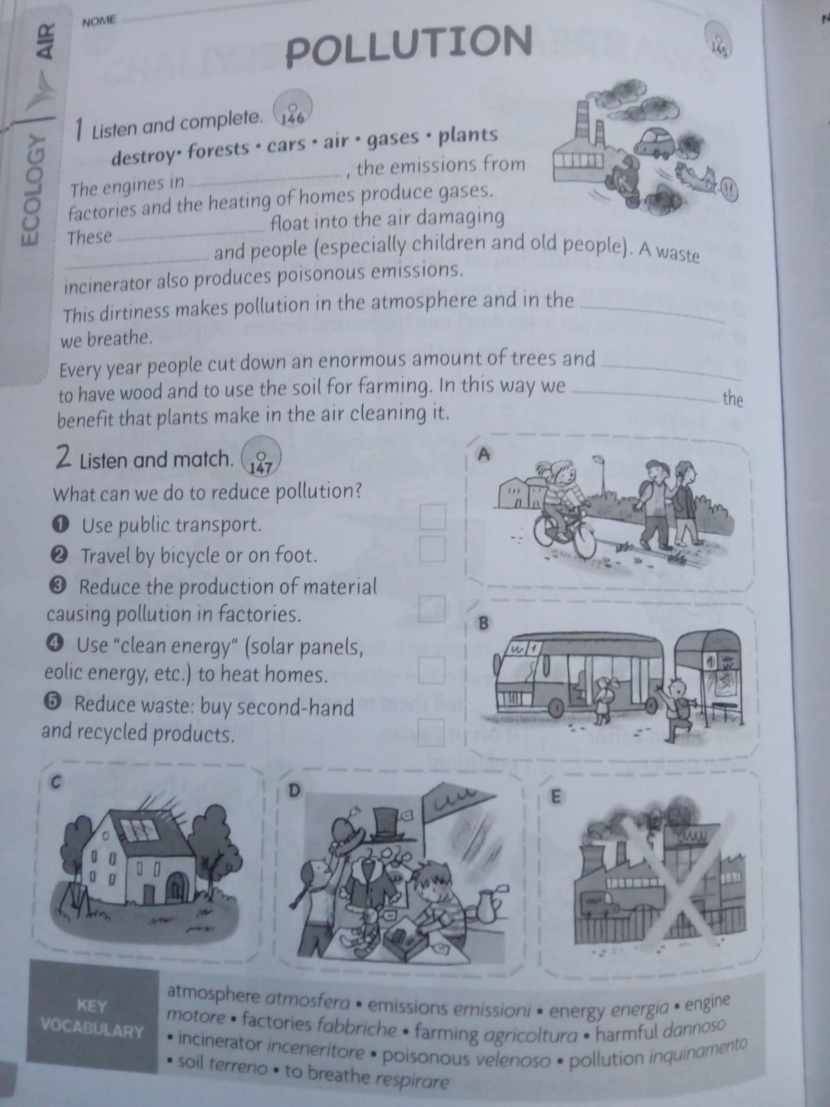

4_Game: mime the “key vocabulary”, game organized in two groups (Time 5 minutes)

5_Build a poster: rewrite/redraft a sort of Brainstorming + key vocabulary

Aim: unit “the knowledge”, what I knew before +what I learn more = what I know now. (Time 20 minutes)

**Lesson 2 “ACOUSTIC POLLUTION “ AND “POLLUTED WATER”**

Language: simple present , and present continuous, used only by the teacher, cooperative work and relationship competences, written competences.

Activities:

1_Warming up --> song about pollution. <https://youtu.be/SIHP-Dv4tGk> Time 5 minutes

2_ Develop skills strategies: students in group of 4/5 complete the text “ACOUSTIC POLLUTION” (p.89). Time 15 minutes

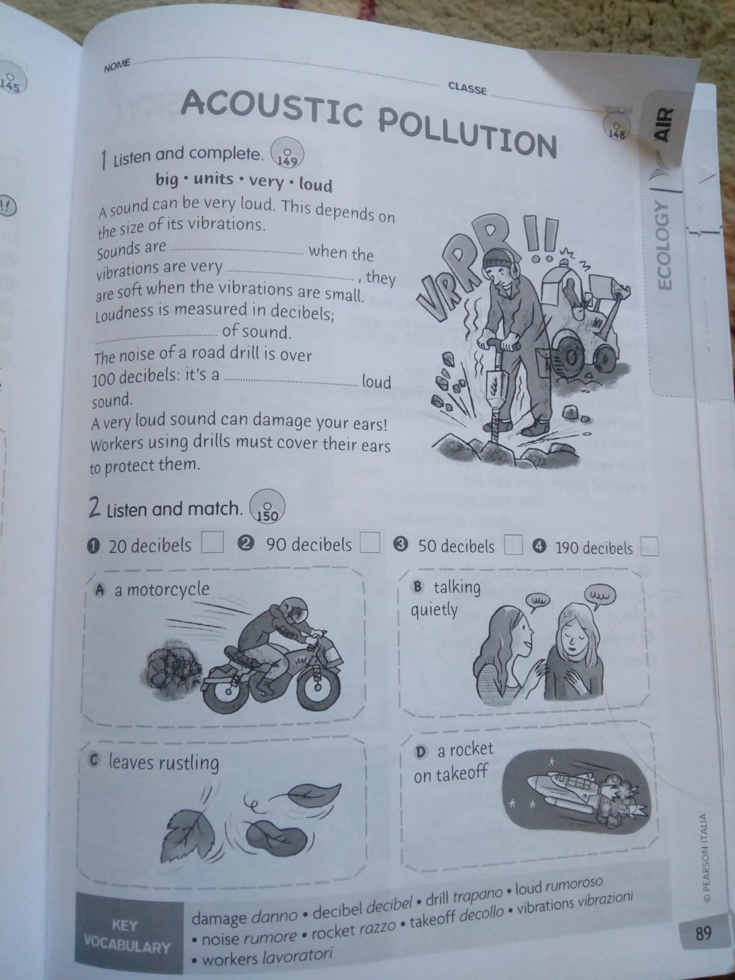

3_Then, read the short text looking for specific information, underline keywords.

Listen + match (exercise in pair). Time 5 minutes

4_Listen and complete “POLLUTED WATER” P. 114

Work in group->they have to listen together and understand the right answer.

Time 10 minutes

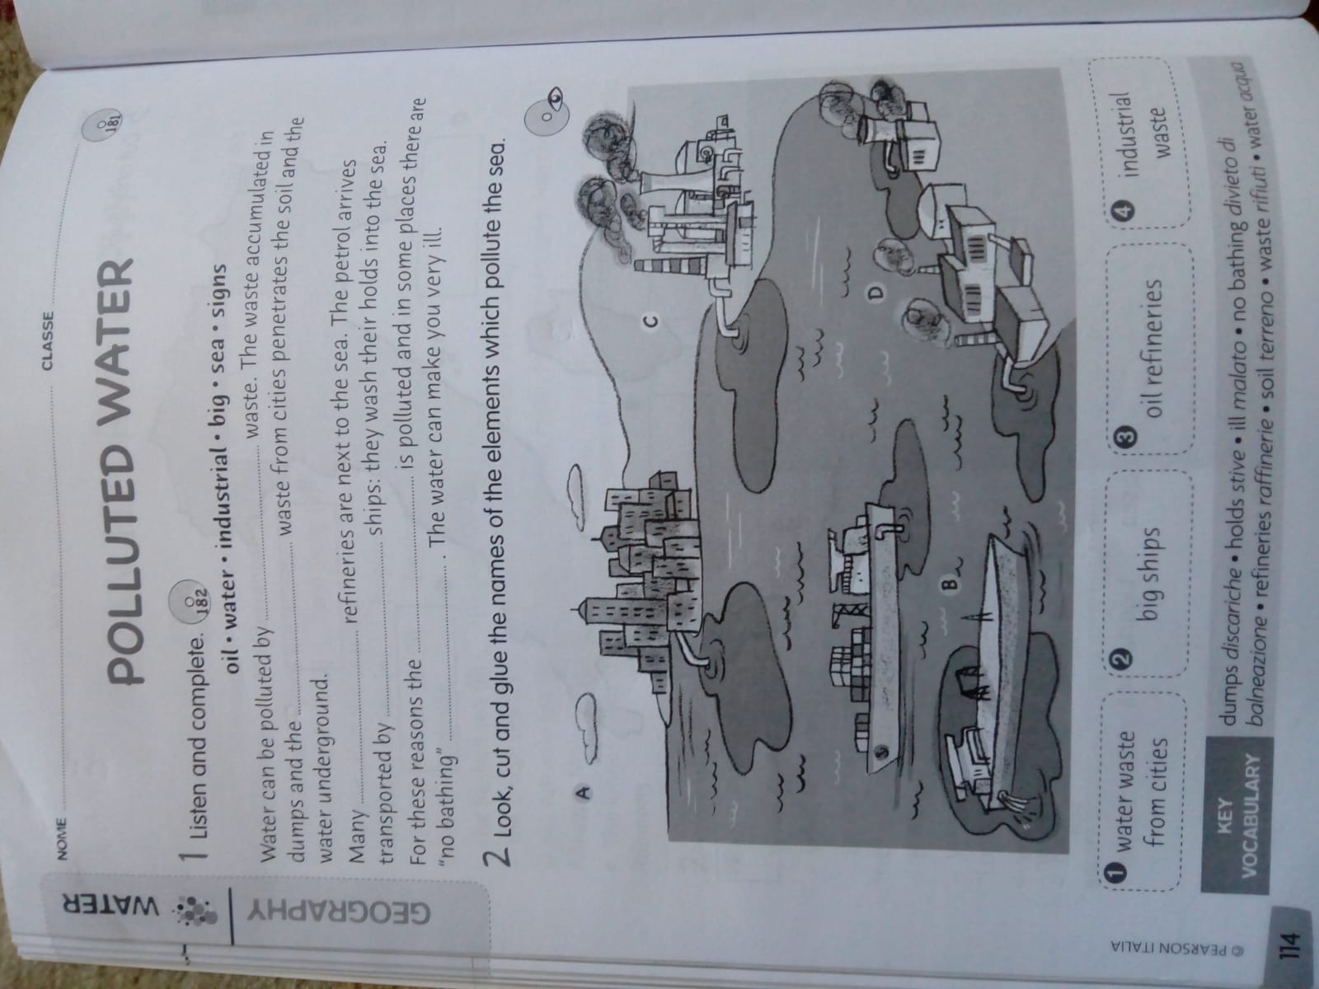

5_Look at the picture and match the words to the elements that pollute the sea - time 15 minutes

+ build a poster with 8 groups of children, 4 groups will make the pictures and write some keywords above them, 4 groups will prepare the elements to match to.

Time 10 minutes.

**Lesson 3 “POLLUTED WATER” part 2**

Language: simple present , and present continuous, used only by the teacher, cooperative and peer-work and relationship competences and development of meta- cognition sphere.

Activities:

1_Warm up --> complete the poster. Time 25 minutes

2_Cooperation-peer work “experiment about POLLUTION” P.130 in group of 3-4 children. 35 minutes

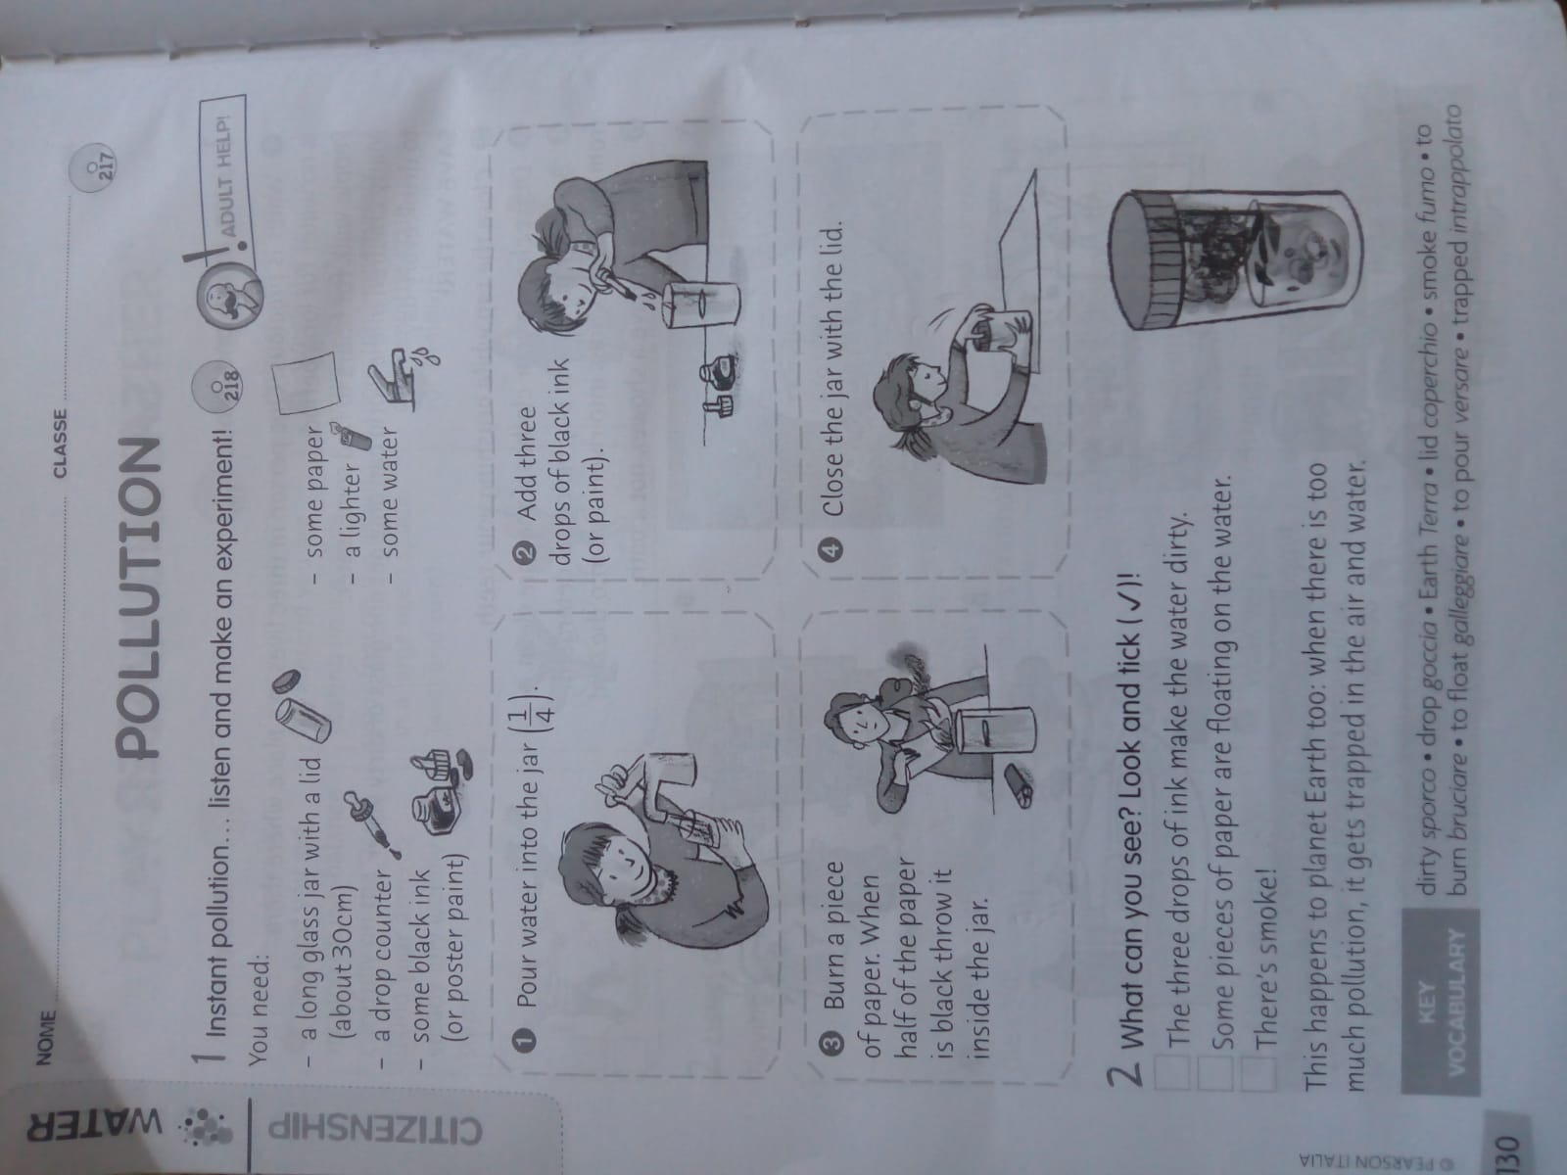

3_ The children have to express some reflections and ideas about the experiment- and in general about water pollution… we will build a poster with some stickers.

4_the children have to express some reflection and ideas about the experiment and in general about water pollution.

**Lesson 4 “RESPECT THE SEA” part 1**

Language: simple present , and present continuous, used only by the teacher, cooperative and peer-tutoring, relationship and oral competences.

Activities:

1_ Warm up: the children are in circle and each one of them take a post-it (not her/his post it, but from another student) and do a comment or a reflection about water pollution, inspired from that post; then can put it in his/her workbook. Time 30 minutes

2_ Listening activity about the theme “respect the sea” p.131, after that we will discuss altogether, time 15 minutes

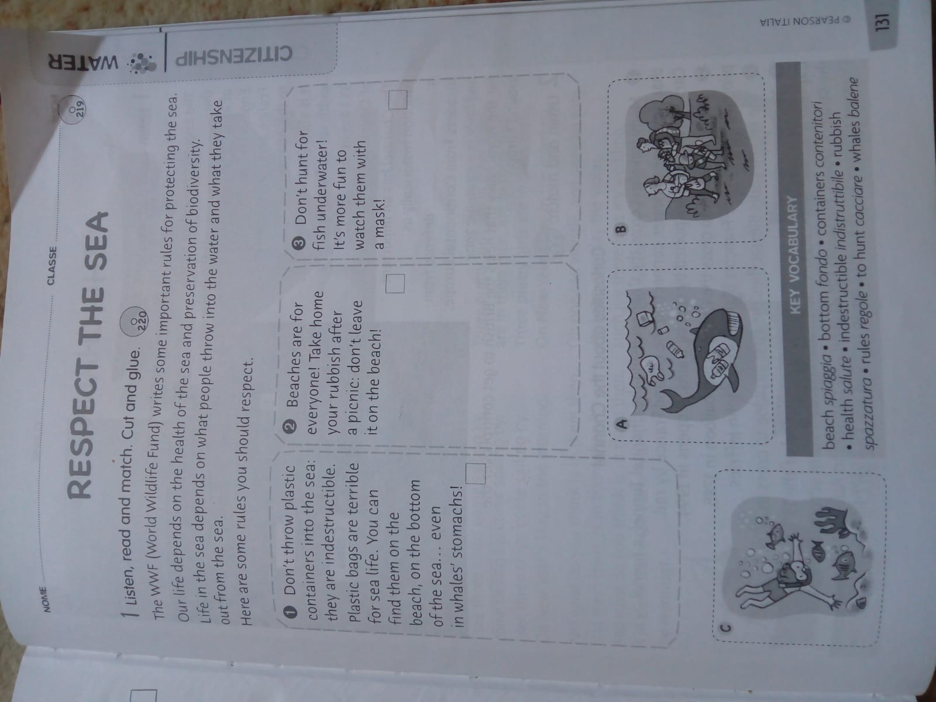

3_ cooperation peer-tutoring: exercises p.131 (match the right rules - choose the correct order - cut and glue on the notebook and find some keywords) - time 15 minutes.

**Lesson 5 “RESPECT THE SEA” part 2**

**and the importance of BIODIVERSITY**

Language: simple present , and present continuous, used only by the teacher, cooperative and peer-tutoring, relationship and oral competences, developing of meta-cognition sphere.

Activities:

1_ Warm up : to build a poster (to hang in the classroom) following the rules of pag. 131.

We’ll divide the class in 6 groups (4 students for group), and each of them will prepare a part. Materials: poster, papers, felt-tips, pencil ect.

Six squares, three with words (writing in dark black the “key words”) and three with pictures. Time 30 minutes

2_Listening comprehension about the importance to defend the biodiversity from the pollution and underline the keywords. P.167 Time 10 minutes

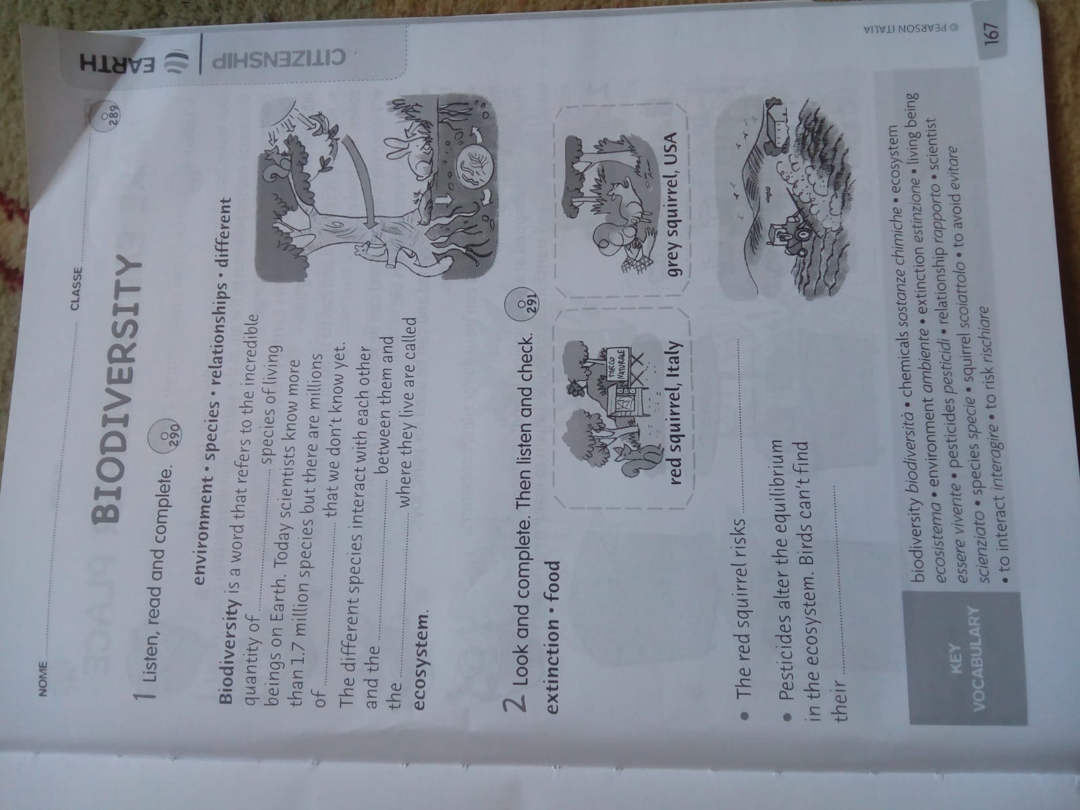

3_ Listen and complete in pair, time 10 minutes

4_Discuss all the connection between biodiversity and pollution. Time 10 minutes

**Lesson 6 “the Greenhouse effect”**

Language: simple present , and present continuous, used only by the teacher, cooperative and peer-tutoring, relationship and oral competences, developing of meta-cognition sphere.

Activities:

1_Warm up: Brainstorming about the“Greenhouse effect”

Questions that can help: What is it? (I will draw a Greenhouse on the blackboard) How does it works? Why is it important? What can happen? (take a picture of the Brainstorming). Time 15 minutes

2_work in pair: listen and complete + underline the keywords. P.47 Time 10 minutes

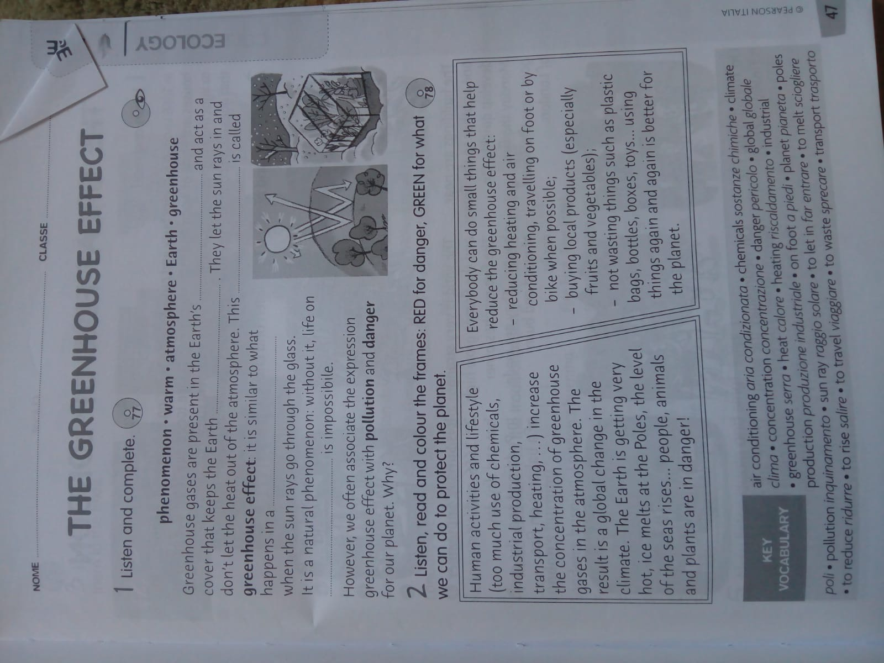

3_work in pair: write on the notebook the brainstorming, dividing the information for sectors. Time 10 minutes What is it?

Greenhouse effect

How does it work? Why is it important?

4_Listen, read and draw; time 10 minutes

5_Build a poster in group, the teacher will divide the text in different parts. Each group can work to prepare a section. They will write the dangers and the opportunities. Time 15 minutes.

H*omework: they have to look for some pictures to cut (from newspapers and magazines) to put on the poster.*

**Lesson 7 “Saving Energy”**

Language: simple present , and present continuous and “conditional” used only by the teacher, cooperative and peer-tutoring, relationship and oral competences, developing of meta-cognition sphere.

Activities:

1_Warm up: end of the 6th lesson: finish the poster of the “greenhouse effect”; (time 20 minutes)

2_Listening exercise, they have to improve their imagination🡪the children will close their eyes and have to imagine some different actions connected to the term “energy saving”p.45 time 5 minutes

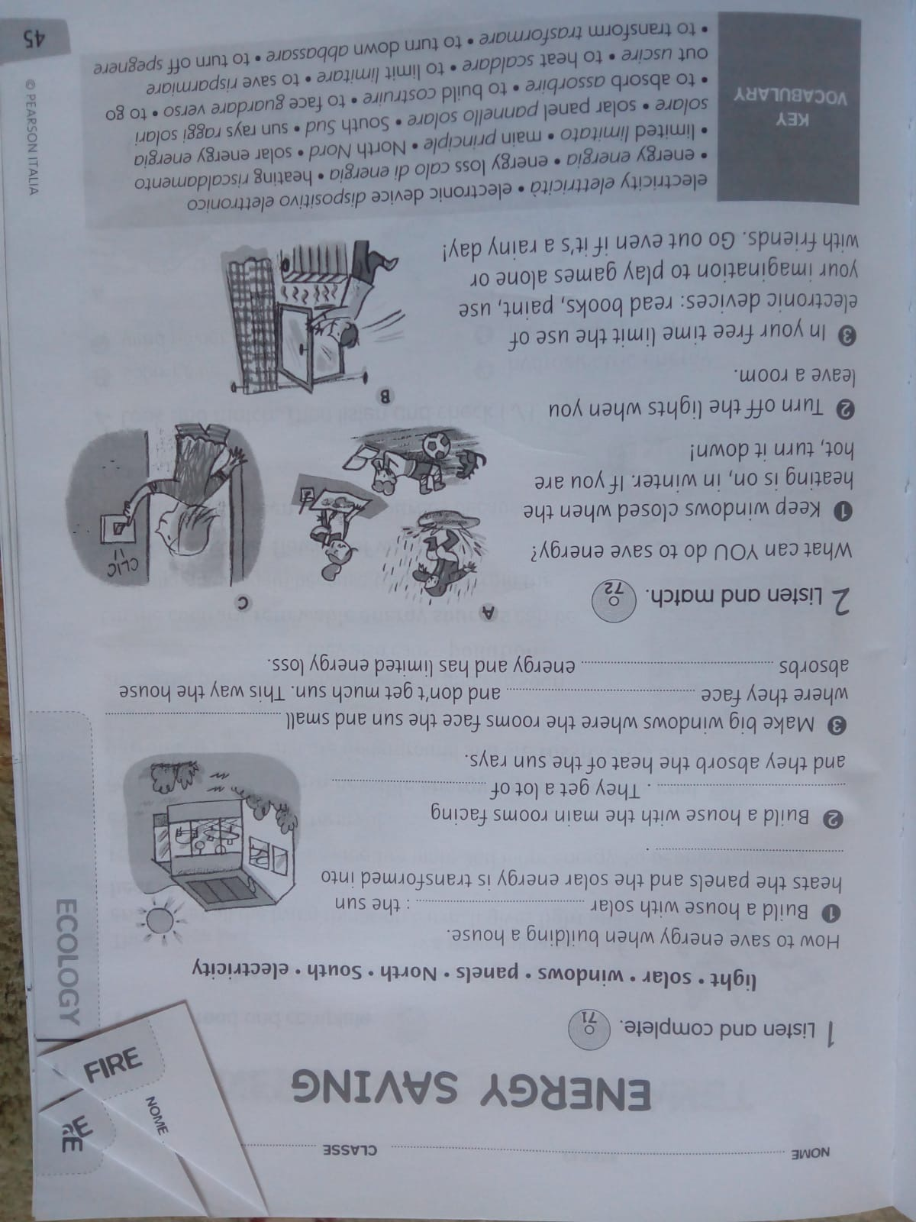

3_Listen and complete in pairs + underline the keywords. Then we’ll read the text altogether and we will discuss about how can be possible to build a “sustainable” house. Time 15 minutes, some images from the internet will be showed.

4_Listen and match. (Time 5 minutes)

5 The children will produce a short video where they can explain how we can save energy.

Time 15 minutes

**Lesson 8 “Saving Water”**

Language: simple present , “conditional” and future used only by the teacher, cooperative and peer-tutoring, relationship and oral competences, developing of meta-cognition sphere.

Activities:

1_Warm up: discussion –What do you know about water?

-Why is it so important?

-Have all the people the same ”access” to the water in the World? If yes, are you sure? If not, why? Time 15 minutes

2_Listen to a passage and look at some images on the Internet, discussion about them (time 15 minutes)

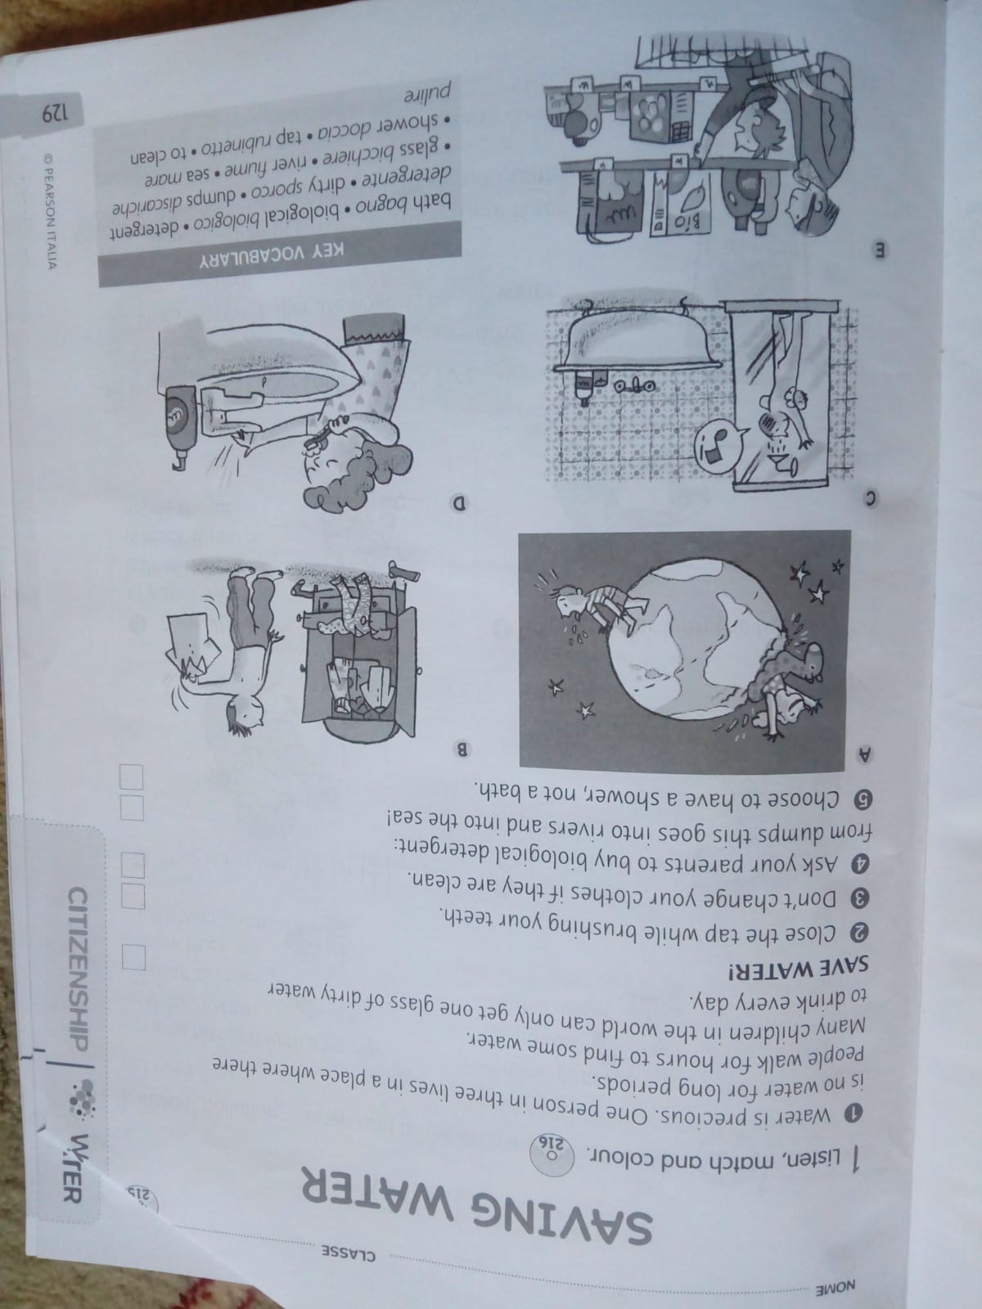

3_”Save Water!”Listen and match, work in group to realize a video with the aim “How we can save water”, act out it i.e. drawing a shower on the blackboard and a child says “ I have a shower not a bath, to save water!”.

Time 20 minutes

4_show some international project like the association Oxfam <https://www.youtube.com/watch?v=BQM_auo7-qk> that help people who haven’t enough water because of drought; time 10 minutes

**Lesson 9 “Make a better place”- Reduce and “Plastic Island in the Ocean”**

Language: simple present , “conditional” and future used only by the teacher, cooperative and peer-tutoring, relationship and oral competences, developing of meta-cognition sphere.

Activities:

1_Youtube: <https://youtu.be/1qT-rOXB6NI> video about the Plastic Island in the Ocean to analyze together the problem of waste and especially of plastic in the sea, discussion about this topic to underline the importance to reduce the waste. Time discussion: 5 minutes

2_introduce the meaning of the verbs: Reduce, Reuse and Recycle; show some pictures on the Interactive Whiteboard.(Time 10 minutes)

3_Analyse the verb: to reduce, brainstorming…how is it possible to reduce our waste? Discussion using images from the internet.(Time 20 minutes)

4_ Reorder the Brainstorming and create a conceptual map on the notebook. Time 15 minutes.

5_ observe and copy some ideas to reduce waste, watching a video and discussing together about the different methods and strategies. <https://www.youtube.com/watch?v=OasbYWF4_S8> (time 15 minutes).

**Lesson 10 “Make a better place”- Reuse**

Language: simple present , and present continuous, “conditional” and future used only by the teacher, cooperative and peer-tutoring, relationship and oral competences, developing of meta-cognition sphere.

Activities:

1_warm up: cooperative work, the children have to work in group of 4/5 students and answer these questions:

Do you reuse anything at your place? If yes, what? Do you have any other ideas? How can we reuse dresses? Boxes? Shoes? Containers? Free your imagination…

They also have to create a kind of conceptual map of what they are discussing. Time 25 minutes

2_Rebuild a summary of all the conceptual maps on the board, with also images from the Internet. (Time 25 minutes).

3_Show a video about how to reuse things in daily life. <https://www.youtube.com/watch?v=zOy1wZvrEzE> (Time 10 minutes)

**Lesson 11 “Make a better place”- Recycle**

Language: simple present , and *present continuous, “conditional” and future used only by the teacher*, cooperative and peer-tutoring, relationship and oral competences, developing of meta-cognition sphere.

Activities:

1_warm up🡪drawing images related to the word “Recycle” (time 10 minutes)

2_Listen to the passage, and discuss about this theme exercise pag.168; (time 20 minutes)

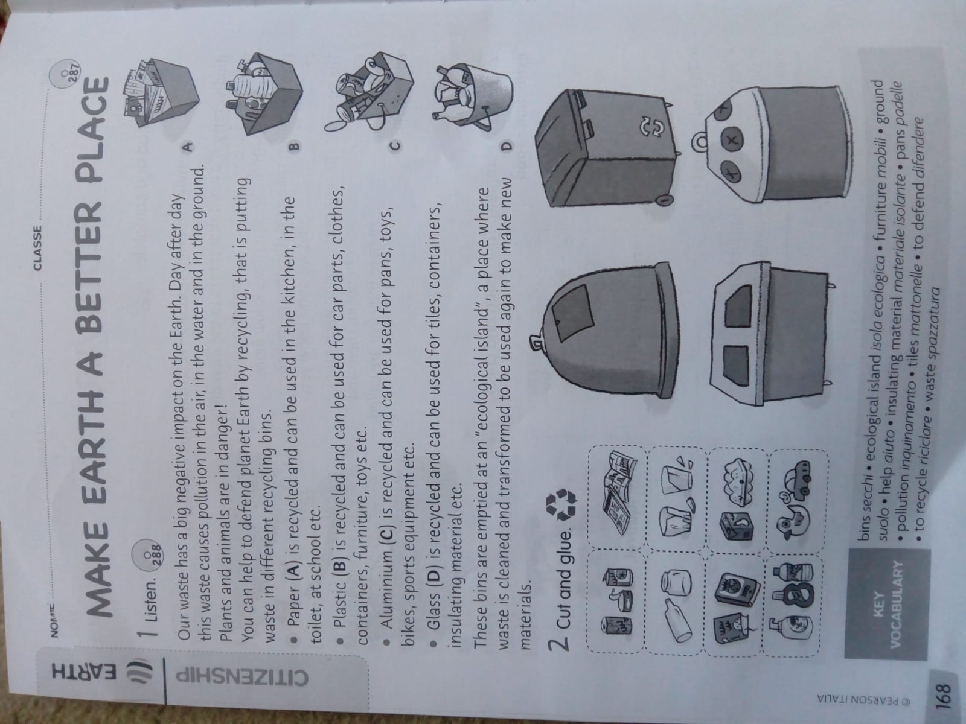

3_ Practical exercise: cut and glue (n°2) and verbalization; time 10 minutes

4_ Realize a poster of “Make a better place” with all the three phases: reduce, reuse, recycle. (time 20 minutes)

**Lesson 12 “Make a better place”:**

***Eat and grow organic food***

***Eat and grow seasonal food***

***Buy at km zero***

Language: simple present , and *present continuous, “conditional” and future used only by the teacher*, cooperative and peer-tutoring, relationship and oral competences, developing of meta-cognition sphere.

Activities:

1_brainstorming: What is it an organic food? Do you know this word? (Time 10 minutes)

2_Build a mind map with the key word “organic food” (time 15 minutes)

3_write together the definition of organic and why it is so important for our healthy and for the environment. (Time 10 minutes)

4_ work in small group of 3/4 children, answer to this question: Why is seasonal food more healthy? (Time 15 minutes)

5_ Why is it better for the environment if you buy food at km zero? (Time 5 minutes)

6_ <https://www.youtube.com/watch?v=BebNsezt6r0> video about organic food.

<https://www.youtube.com/watch?v=C5B2sYIdCVk> seasonal food.

**Lesson 13“Realize a unique poster”**

Language: simple present , and *present continuous, “conditional” and future used only by the teacher*, cooperative and peer-tutoring, relationship and oral competences, developing of meta-cognition sphere

The children prepare a big poster that includes all the aspects of the main theme: “How to take care of our planet”. (Time 1 hour)