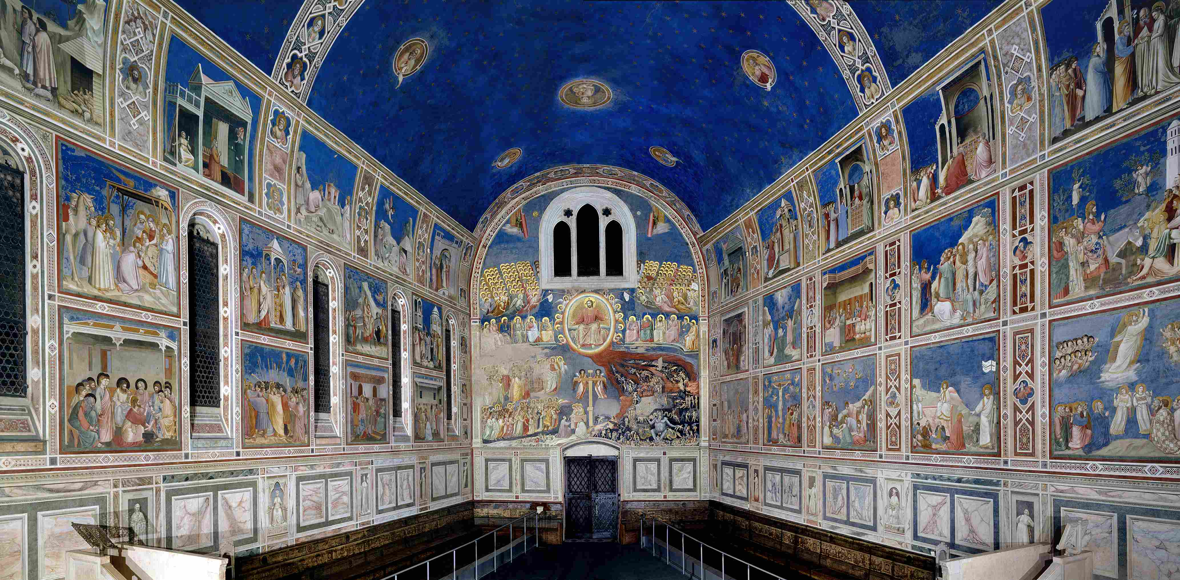

ISTITUTO COMPRENSIVO DI SOCI

*Scuola Secondaria di Primo Grado*

***CLIL PROJECT: GIOTTO***

***school year 2016-2017***

Boldrini Gigliola (English teacher)

Barbagli Sonia (Art teacher)

**Classes: 2A, 2B**

|  |  |  |  |  |  |
| --- | --- | --- | --- | --- | --- |
| **Unit 1** | **GIOTTO DA BONDONE** | | | |  |
| **Level** 2nd classes (A2) | **Lessons** 4 | **Lessons timing** 60’ | | **Unit timing** 4h |
| **AIMS** | | | **ASSESSMENT** | |
| To introduce the students in the world of Art in English  To learn about famous painters, their artworks and the art movement  To learn about Giotto’s life, techniques, masterpieces | | | Self assessment  Teacher assessment | |
| **Teaching objectives** | | | **Materials** | |
| To know the artist, his life, his masterpieces and their features  To know his innovation in the world of art  To strengthen comunicative competence in different contexts in order to acquire disciplinary content and to be able to develop critical thoughts  To observe and compare data and / or information  To select and classify data and / or information  To listen and understand specific information  To read and understand descriptive texts to obtain specific information | | | Video <http://www.italian-renaissance-art.com/Giotto.html>  Worksheet 1: Biography of Giotto  Worksheet 2: Grid to fill in  Glossary | |
| **Basic competences/SKILLS** | | | | |
| **Communicative**   * To improve linguistic and audio-visual competences * To improve comunicative competences in artistic and cultural fields * To ask and give simple information about the artist and his paintings * To understand, perceive and to be able to value, critically, different cultural and artistic forms of expression   **Methodological**   * Learning to learn: to apply study skills that include strategic thinking, cooperation and self-evaluation skills * Problem solving * To develop meta-cognitive reflection and cognitive self-assessment * To identify, select and group   **Personal**   * To improve autonomy, initiative and decision taking * To develop creativity in carrying out projects * To strengthen and improve logical skills for hypotheses and deductions | | | | |

|  |  |  |  |
| --- | --- | --- | --- |
| **LEARNING OUTCOMES** | | | |
| **Content** | | **Cognition** | |
| To introduce the artist to the students  To know Giotto’s biography and discuss about it  To know his masterpieces and techniques | | Brainstorming  Reading and answer questions - Key vocabulary  Fill in a grid in the lab  Match the words/expressions - Listen and complete…  Find the differences/Compare  Speaking: introduce the topic | |
| **Culture** | | | |
| Awareness of the main features in Giotto’s masterpieces  Make comparisons between Giotto’s new ideas and the previous concept of art  To be able to analyse a work of art and appreciate its artistic value | | | |
| **Communication**  Learn to comunicate and exchange ideas about Giotto, his technique, the new idea of art | | | |
| **Language OF learning** | **Language FOR learning** | | **Language THROUGH learning** |
| Key words  Expressions for describing paintings | Locating things/people in describing a landscape, a scenery  Speaking about colours, art techniques  Making comparaisons (between two paintings)  Expressing opinion, feelings | | Give instructions  Language in classroom activities |

|  |  |  |  |  |  |
| --- | --- | --- | --- | --- | --- |
| **Unit 2** | **GIOTTO DA BONDONE: analysis of the fresco cycles in the Scrovegni Chapel (Padua)** | | | |  |
| **Level** 2nd classes  (A2) | **Lessons** 4 | **Lessons timing** 60’ | | **Unit timing** 4h |
| **AIMS** | | | **ASSESSMENT** | |
| To learn about famous painters, their artworks and the art movement | | | Self assessment  Teacher assessment | |
| **Teaching objectives** | | | **Materials** | |
| To know the artist, his life, his masterpieces and their features  To know his innovation in the world of art  To be able to read and analyse the fresco cycles, describe the scenes and discuss about that | | | Video  Worksheet 1: Biography of Giotto  Glossary  Reproduction of the cycle of frescoes in the Scrovegni Chapel (Padua) | |
| **Basic competences/SKILLS** | | | | |
| **Communicative**   * To improve linguistic and audio-visual competences * To improve comunicative competences in artistic and cultural fields * To ask and give simple information about the artist and his paintings, in particular about the fresco cycles in Padua * To understand, perceive and to be able to value, critically, different cultural and artistic forms of expression   **Methodological**   * Learning to learn: to apply study skills that include strategic thinking, cooperation and self-evaluation skills * Problem solving * To develop meta-cognitive reflection and cognitive self-assessment * To identify, select and group   **Personal**   * To improve autonomy, initiative and decision taking * To develop creativity in carrying out projects * To strengthen and improve logical skills for hypotheses and deductions | | | | |

|  |  |  |  |
| --- | --- | --- | --- |
| **LEARNING OUTCOMES** | | | |
| **Content** | | **Cognition** | |
| To analyse “The mourning of the dead Christ” in detail  To be able to understand a painting and describe it to the classmates  To be able to understand all the fresco cycles in the Scrovegni Chapel  To apply art vocabulary and artistic concepts  To analyse and compare artworks by different artists  To reproduce one of the depicted scenes and to be able to describe it | | Brainstorming  Reading and answer questions - Key vocabulary  Fill in a grid in the lab  Match the words/expressions - Listen and complete  Find the differences/Compare  Analyse other masterpieces and describe them  Speaking: introduce the introduced topic (one chosen scene of the fresco) to the class | |
| **Culture** | | | |
| Awareness of the main features in Giotto’s masterpieces  Make comparisons between Giotto’s new ideas and the previous concept of art  To be able to analyse a work of art and appreciate its artistic value  To respect and value different artist’s works | | | |
| **Communication**  Learn to comunicate and exchange ideas about Giotto, his technique, the new idea of art | | | |
| **Language OF learning** | **Language FOR learning** | | **Language THROUGH learning** |
| Key words  Expressions and words for describing paintings | Locating things/people in describing a landscape, a scenery  Speaking about colours, art techniques  Making comparaisons (between two paintings)  Expressing opinion, feelings | | Give instructions  Language in classroom activities |

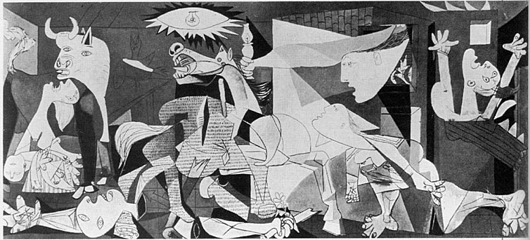

ISTITUTO COMPRENSIVO DI SOCI

Scuola Secondaria di Primo Grado

***CLIL PROJECT: PICASSO***

***school year 2016-2017***

Boldrini Gigliola (English teacher)

Barbagli Sonia (Art teacher)

**Classes: 3A, 3B**

|  |  |  |  |  |  |
| --- | --- | --- | --- | --- | --- |
| **Unit 1** | **PABLO PICASSO: life, techniques, masterpieces** | | | |  |
| **Linguistic Level** A2/B1(3rd classes ) | **Lessons**  2 | **Lessons timing** 60’ | | **Unit timing** 2h |
| **AIMS** | | | **ASSESSMENT** | |
| To learn about famous painters, their artworks and the art movement | | | Self assessment  Teacher assessment | |
| **Teaching objectives** | | | **Materials** | |
| To know the artist, his life, his masterpieces and their features  To know his innovation in the world of art  To strengthen comunicative competence in different contexts in order to acquire disciplinary content and to be able to develop critical thoughts  To observe and compare data and / or information  To select and classify data and / or information  To listen and understand specific information  To read and understand descriptive texts to obtain specific information  To answer written questions, complete texts, tables, know and use the specific vocabulary on Cubism, Art and Image | | | Video <http://www.raiscuola.rai.it>  PPP: Picasso:from his early formation to surrealism  Worksheet 1: Read and match  Worksheet 2: Fill in a grid  Glossary | |
| **Basic competences/SKILLS** | | | | |
| **Communicative**   * To improve linguistic and audio-visual competences * To improve comunicative competences in artistic and cultural fields * To ask and give simple information about the artist, his career and his paintings * To understand, perceive and to be able to value, critically, different cultural and artistic forms of expression   **Methodological**   * Learning to learn: to apply study skills that include strategic thinking, cooperation and self-evaluation skills * Problem solving * To develop meta-cognitive reflection and cognitive self-assessment * To identify, select and group   **Personal**   * To improve autonomy, iniziative and decision taking * To develop creativity in carrying out projects * To strengthen and improve logical skills for hypotheses and deductions | | | | |

|  |  |  |  |
| --- | --- | --- | --- |
| **LEARNING OUTCOMES** | | | |
| **Content** | | **Cognition** | |
| To introduce the artist to the students.  To read and learn his artistic life, the remarkable periods in his career, to learn about Cubism and its features.  To be able to understand a work of art, identify compositional elements, use of special technique for creative tasks and describe it to the classmates | | Identifying, classifying, analyzing, synthesizing and evaluating painting elements | |
| **Culture** | | | |
| Awareness of Picasso’s life, the evolution in his career, the main features in his masterpieces  Being aware of the role of Cubism  To be able to analyse a work of art and appreciate its artistic value | | | |
| **Communication**  Learning to comunicate and exchange ideas about Picasso, his technique, the new idea of art  Developing new vocabulary related to the language of art and drawing  Using new acquired vocabulary in context | | | |
| **Language OF learning** | **Language FOR learning** | | **Language THROUGH learning** |
| Key words  Describing paintings | Locating things/people in describing a landscape, a scenery  Speaking about colours, art techniques  Making comparaisons (between two paintings)  Expressing opinions, feelings | | Give instructions  Language in classroom activities |

|  |  |  |  |  |  |
| --- | --- | --- | --- | --- | --- |
| **Unit 2** | **PICASSO: *GUERNICA*** | | | |  |
| **Level** A2/B1  (3rd classes) | **Lessons** 2 | **Lessons timing** 60’ | | **Unit timing** 2h |
| **AIMS** | | | **ASSESSMENT** | |
| To learn about famous painters, their artworks and the art movement | | | Self assessment  Teacher assessment | |
| **Teaching objectives** | | | **Materials** | |
| To know the artist, his life, his masterpices and their features  To know his innovation in the world of art  To watch and read an artwork from the early twentieth century: Guernica di Picasso, to learn about Cubism  To be able to analyse the painting, to describe the main features, symbols and discuss about that | | | Video: [*youtube* Guernica Pablo Picasso - Guernica (1937) Art History Online](https://www.youtube.com/results?q=youtube+Guernica+Pablo+Picasso+-+Guernica+%281937%29+Art+History+Online) Worksheet 1: Guided questions to peers  Worksheet 2: Grid to fill in  Worksheet 3: how to read the painting (grid to fill in about the symbols in the painting)  Glossary | |
| **Basic competences/SKILLS** | | | | |
| **Communicative**   * To improve linguistic and audio-visual competences * To improve comunicative competences in artistic and cultural fields * To ask and give simple information about the artist and his paintings * To understand, perceive and to be able to value, critically, different cultural and artistic forms of expression   **Methodological**   * Learning to learn: to apply study skills that include strategic thinking, cooperation and self-evaluation skills * Problem solving * To develop meta-cognitive reflection and cognitive self-assessment * To identify, select and group   **Personal**   * To improve autonomy, initiative and decision taking * To develop creativity in carrying out projects * To strengthen and improve logical skills for hypotheses and deductions | | | | |

|  |  |  |
| --- | --- | --- |
| **LEARNING OUTCOMES** | | |
| **Content** | **Cognition** | |
| To read of a work of art of the early xxth century: a painting, Guernica by Picasso  To learn about Cubism  To create an artwork | Brainstorming  Reading and answer questions - Key vocabulary  Fill in a grid in the lab  Match the words/expressions  Listen and complete…  Find the symbols and write them in a grid  Find the differences/Compare  Speaking: introduce the painting to the class (explaining the images and the symbols) | |
| **Culture** | | |
| Awareness of the main features in Picasso’s masterpieces  Make comparisons between Picasso’s new technique and the previous concept of art  To be able to analyse a work of art and appreciate its artistic value | | |
| **Communication**  Learn to communicate and exchange ideas about Picasso, his technique, the new idea of art  Talk about personal reactions in front of a work of art (like/dislike) | | |
| **Language OF learning** | **Language FOR learning** | **Language THROUGH learning** |
| Key words  Describing paintings | Locating things/people in describing a painting  Speaking about colours, art techniques  Expressing the value of symbolism and understand the used symbols  Making comparaisons (between two paintings of his production)  Expressing opinions, feelings | Give instructions  Language in classroom activities |